# Home Work-02: House Price Prediction using Deep Learning

**Task and Goals:**

1. Run the basic train and find most feasible hyper parameters

> a) find feasible learning rate, activation and optimizer function, epoch size

> b) find the correlation of the features, explain the distribution to understand the relationship between house features and how these variables are used to predict house price.

2. Check the model to generalize for new data.

**Summary:**

* The shallow NN with Adam will be able to perfectly predict the unknown house prices.

**Solution:**

1. **Import Libraries**

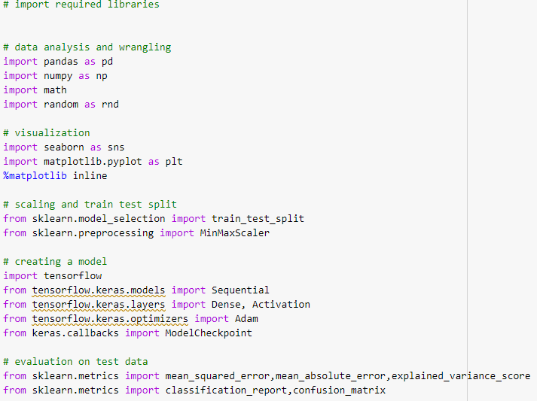

1. **Load dataset**



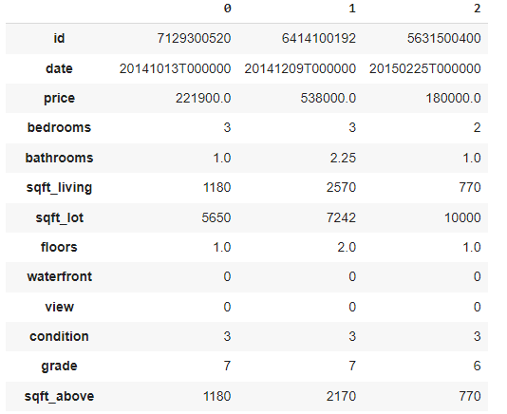

 

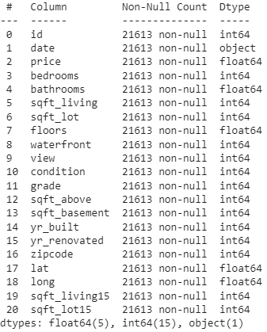

1. Data Preprocessing

 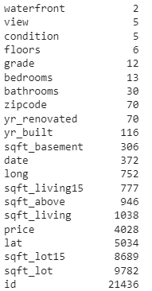

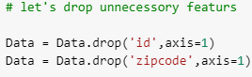  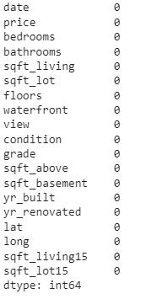



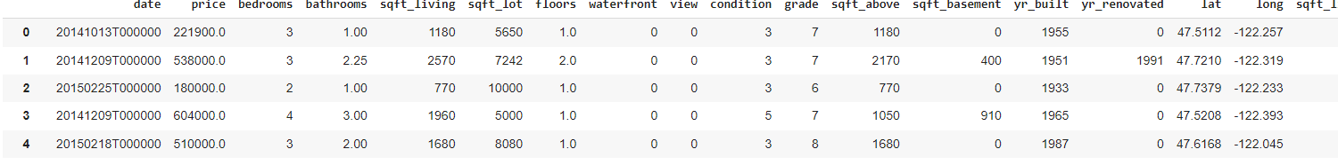

1. Explanatory Data Analysis

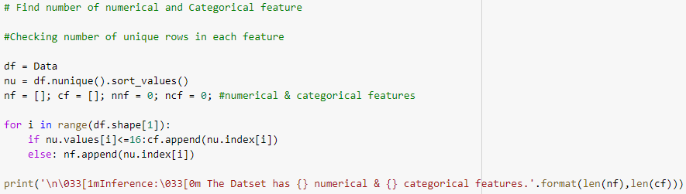



* **Correlation coefficient can range in value from −1 to +1. The larger the absolute value of the coefficient, the stronger the relationship between the variables**

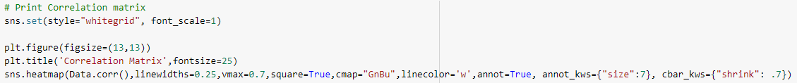

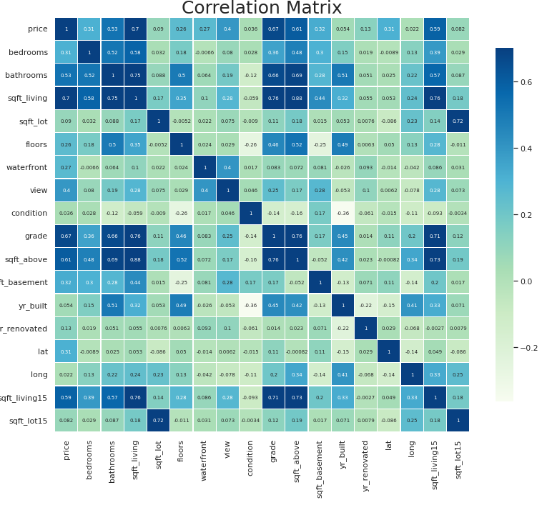

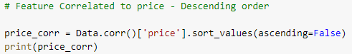

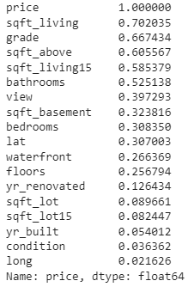

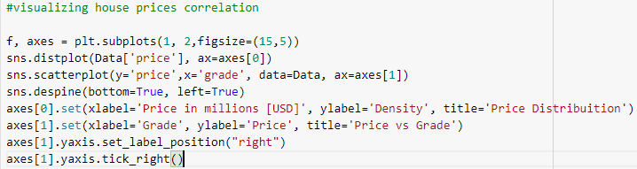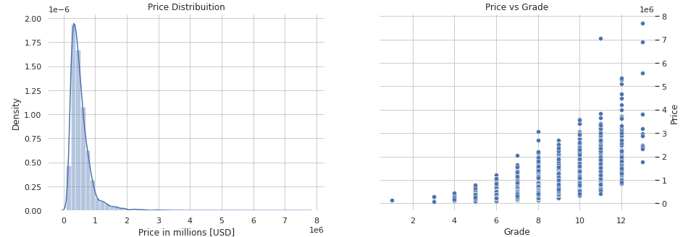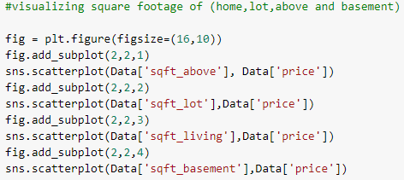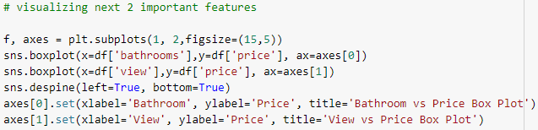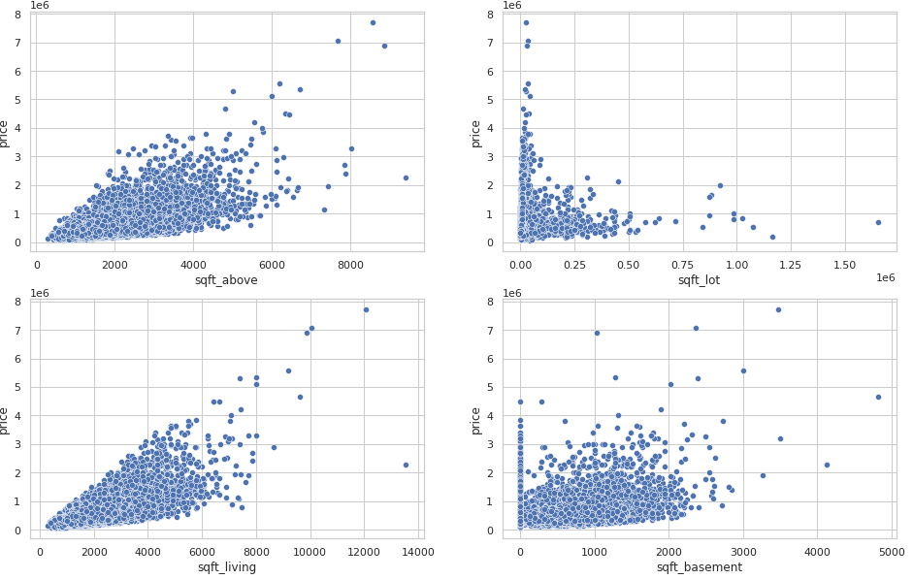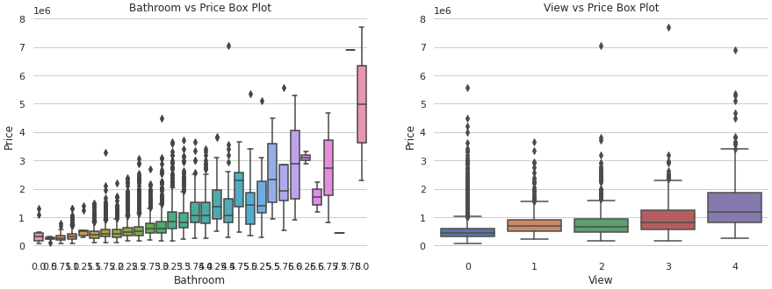 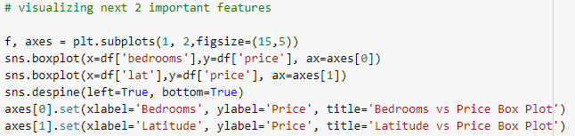

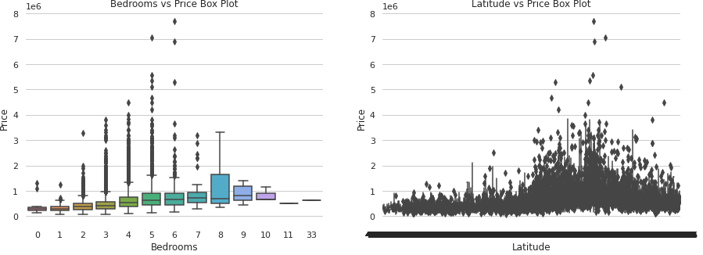

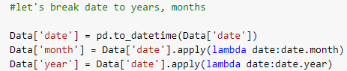

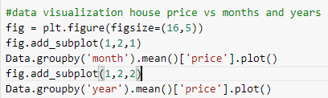 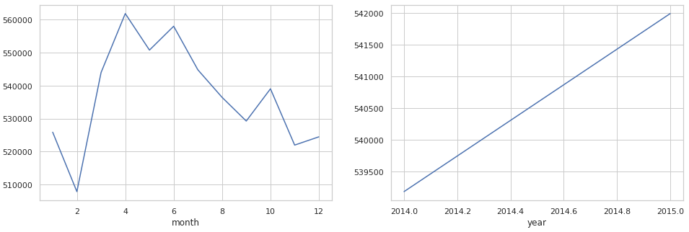

1. **Removing Outliers excluding 25%-75%**

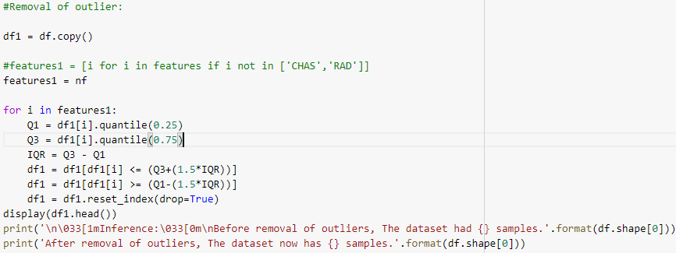 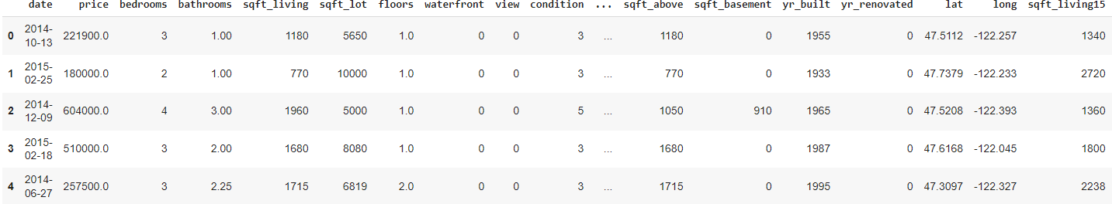

1. **Data Normalization, Scaling and Test/Train Split**

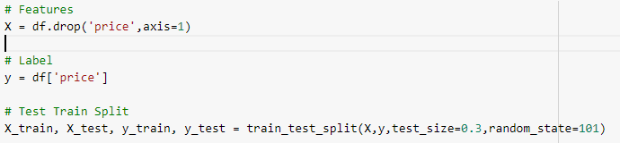 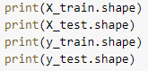 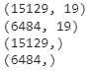



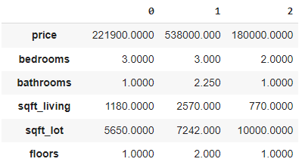

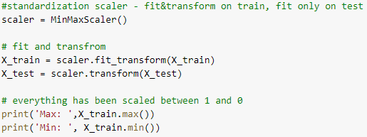 

1. **Define the model**

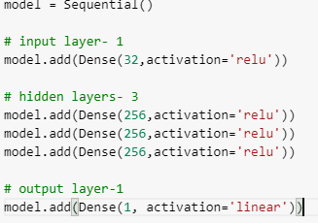



**8) Compile the model**

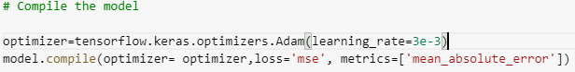

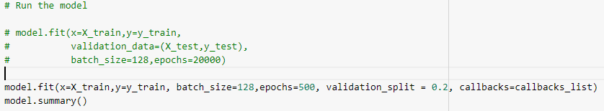

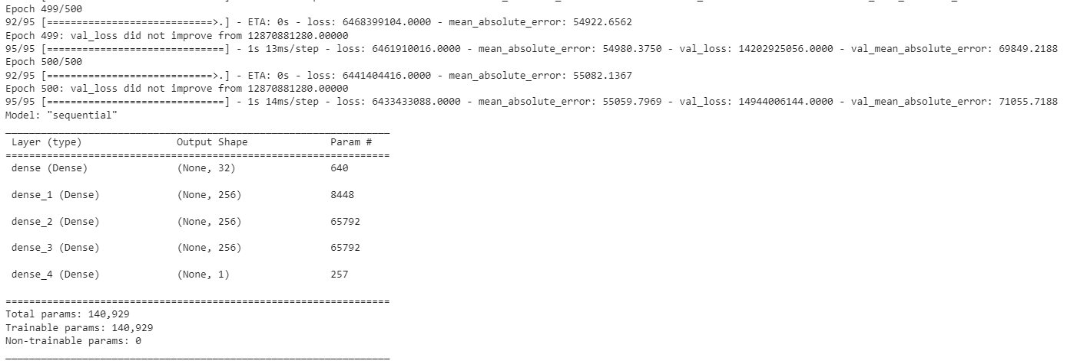

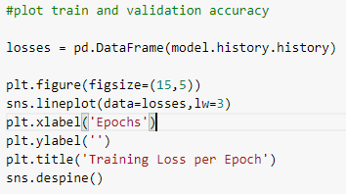 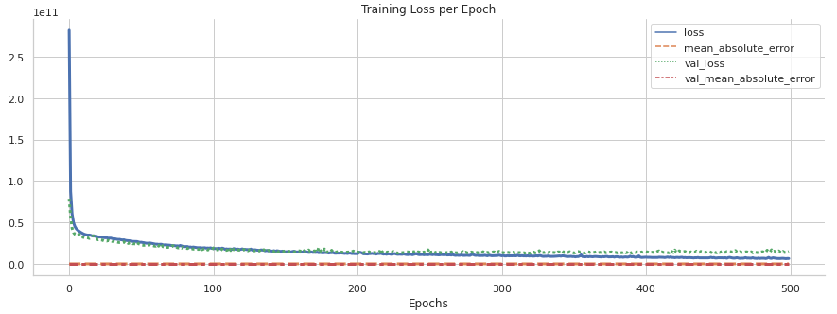

1. **Test the model**

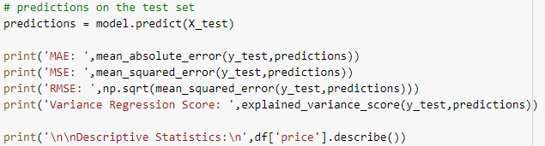

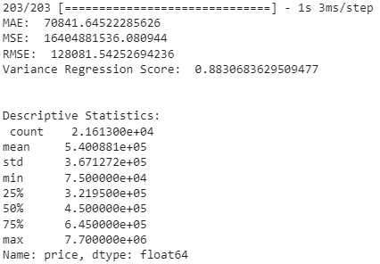

1. **Model Predictor vs. Perfect fit**

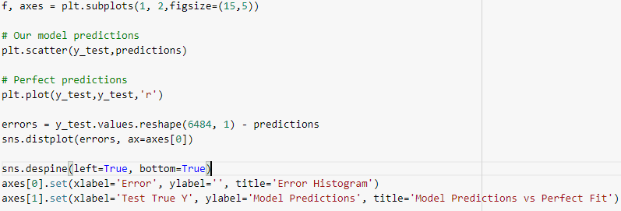 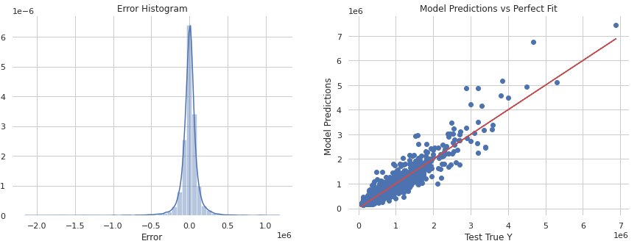

1. **Predicting on a brand-new data**

